Week 4: May 4th to May 8th
Hello Coyotes, here is another fun challenge to get involved in. This is another tool to help you get 30mins of recommended Physical Activity each day. Waylon wants us to stay active and take care of ourselves each day. Exercise is a great way to do it. Get 2 full lines on your card and email crystal.bourgoin@nbed.nb.ca. I will put all names in a hat and do a draw for a prize! Special mail delivery .
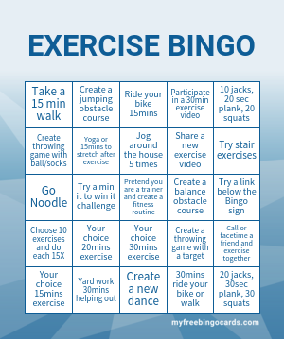
Sites to try: https://teachmama.com/minute-win-games-kids-family/
https://family.gonoodle.com/
https://phecanada.ca/activate/phe-home-learning-centre/physical-education-activities

